Medical Review
Medical Review Overview
The Medical Review feature in SPICE is an essential tool designed for healthcare professionals. It enhances the ability to assess, monitor, provide preventive care, achieve early diagnosis, and facilitate continuous treatment and decision-making, particularly for patients with chronic conditions like hypertension, diabetes, malaria, HIV, and tuberculosis. It also addresses other health services such as maternal and child health, mental health, and immunization.
This feature enables healthcare providers to conduct medical reviews seamlessly, prescribe treatment plans and medications, recommend lab tests, and maintain comprehensive documentation of patients' health profiles. Moreover, it empowers primary care providers to deliver thorough, long-term solutions, ultimately optimizing healthcare delivery in underserved communities and making healthcare practices more efficient and effective.
Medical Review Workflow
- Ensure an active internet connection and sign in to the SPICE mobile app using your SPICE credentials.
- Navigate to the 'Home' page and select 'My Patients' to initiate the process.
- Select 'Start Medical Review' for the specific patient under the 'My Patients' section.
- Follow the intuitive workflow to document necessary details, diagnose the patient, and establish a treatment plan.
- In case of prescriptions or lab tests, search for the required medication or test, add it, and follow the subsequent steps to confirm.
- Sign and confirm the prescriptions when prompted.
- After review completion, click on 'Submit' to save the changes.
The Medical Review feature allows for two distinctive workflows - the First Medical Review and the Continuous Medical Review. The First Medical Review entails the initial thorough check-up of the patient, diagnosis confirmation, capturing details of current lifestyle, medication, comorbidities, complications, physical examination results, and formulating a suitable treatment plan. The Continuous Medical Review enables the follow-up with the patient, noting their ongoing medical condition, reviewing lab test results, prescribing medication, and updating the treatment plan as required.
Medical Review Workflow
- Ensure an active internet connection and sign in to the SPICE mobile app using your SPICE credentials.
- Navigate to the 'Home' page and select 'Medical Review' to initiate the process.
- For a first-time review, fill in the various parameters of the 'First Medical Review Form' and for a follow-up visit, select 'Start Medical Review' for the specific patient under the 'My Patients' section.
- Follow the intuitive workflow to document necessary details, diagnose the patient, and establish a treatment plan.
- In case of prescriptions or lab tests, search for the required medication or test, add it, and follow the subsequent steps to confirm.
- Sign and confirm the prescriptions when prompted.
- After review completion, click on 'Submit' to save the changes.
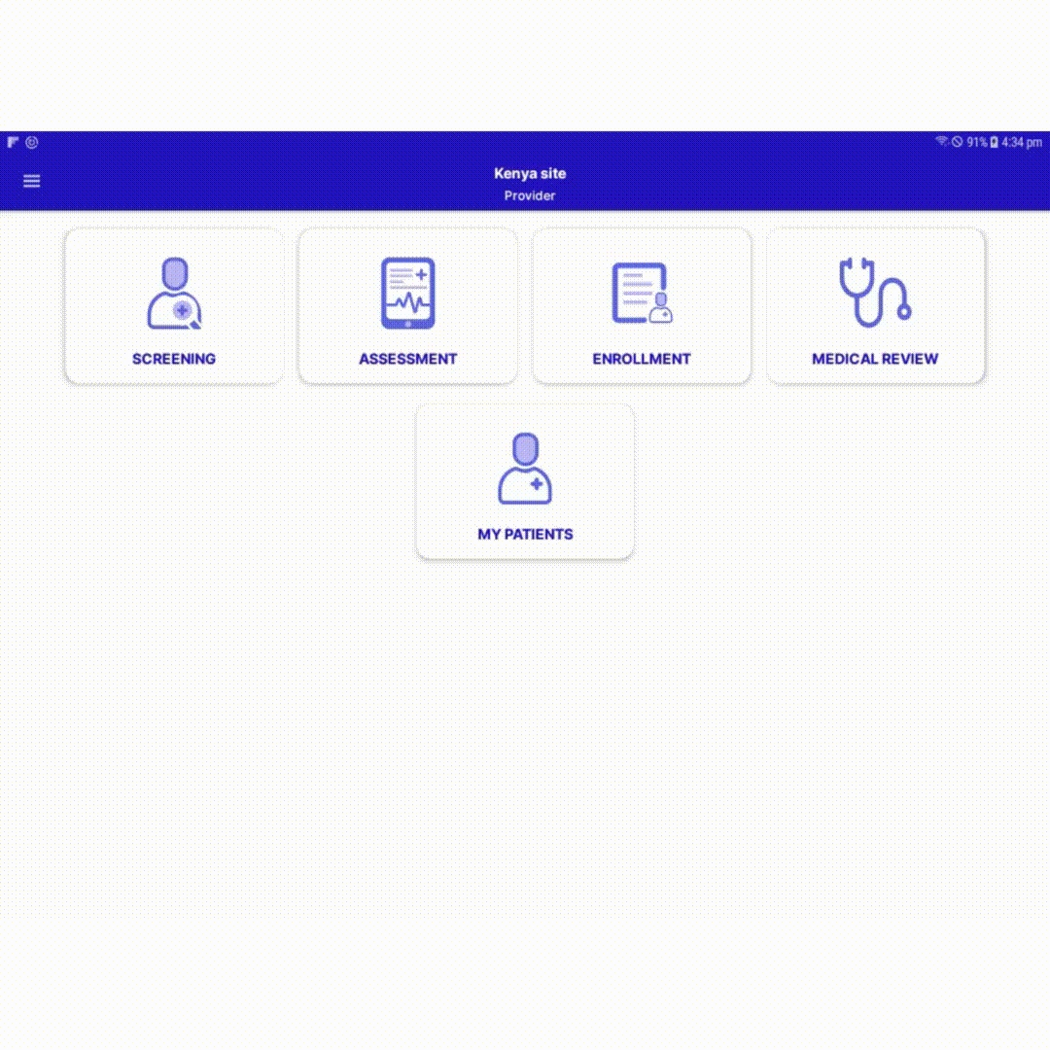
Conduct a Medical Review for the patient in SPICE

